What is an Inner Class?
- An inner class in Java is a class defined within another class. It's also called a nested class.
- Inner classes can access members (fields and methods) of their enclosing or outer class, including private members.
Types of Inner Classes:
There are four main types of inner classes in Java:
- Member Inner Class
- Static Nested Class
- Local Inner Class
- Anonymous Inner Class

Member Inner Class:
- A member inner class is defined within the scope of an outer class.
- It can access both static and non-static members of the outer class.
- It is instantiated using an instance of the outer class.

public class App {
public static void main(String[] args)
{
OuterClass.Inner in=new OuterClass().new Inner();
in.innerMethod();
}
}
class OuterClass
{
private int outerField;
public class Inner {
public void innerMethod() {
// Inner class can access outer class members
outerField = 10;
System.out.println(outerField);
}
}
}

Local Inner Classes
- A local inner class is defined within a method or a block.
- It has limited scope and can only be accessed within the method or block where it's defined.

public class App {
public static void main(String[] args)
{
Outer x = new Outer();
x.outerMethod();
}
}
class Outer {
public void outerMethod() {
System.out.println("outer Method");
class LocalInner {
public void innerMethod() {
System.out.println("inner Method");
}
}
LocalInner y = new LocalInner();
y.innerMethod();
}
}

Static Nested Class
- A static nested class is declared as a static member of the outer class.
- It can only access static members of the outer class.
- It can be instantiated without an instance of the outer class.

public class App {
public static void main(String[] args)
{
Outer.StaticNested.nestedMethod();
}
}
class Outer {
private static int staticField;

public static class StaticNested {
public static void nestedMethod() {

staticField = 20;
System.out.println(staticField);
}
}
}

Anonymous Inner Class: An anonymous inner class can be useful when making an instance of an object with certain "extras" such as overloading methods of a class or interface,
Java Anonymous inner class can be created in two ways:
- Class (may be abstract or concrete).
- Interface
Example Using Abstract Class
abstract class Utilities{
abstract void display();
}
public class App {
public static void main(String[] args)
{
Utilities p=new Utilities()
{
void display()
{
System.out.println("Good Morning");
}
};
p.display();
}
}
Example Using Interface
interface Utilities{
public void display();
}
public class App {
public static void main(String[] args)
{
Utilities p=new Utilities()
{
public void display()
{
System.out.println("Good Morning");
}
};
p.display();
}
}

Final and Static Modifier
Final Access Modifier is a modifier applicable to classes, methods, and variables. If we declare a parent class method as final then we can’t override that method in the child class because its implementation is final and if a class is declared as final we can’t extend the functionality of that class i.e we can’t create a child class for that class i.e inheritance is not possible for final classes. Every method present inside the final class is always final by default but every variable present inside the final class need not be final. The main advantage of the final keyword is we can achieve security and we can provide a unique implementation. But the main disadvantage of the final keyword is we are missing key benefits of OOPs like Inheritance(Because of the final class)
final int constantValue = 42;//final variable

class Parent {
final void finalMethod() {
// Method implementation
}
}

final class FinalClass {
// Class members and methods
}

Static Modifier:
- The static modifier is used to create members (fields or methods) that belong to the class itself, rather than to a specific instance of the class.
- A static method can be called on the class itself, without needing an instance of the class.
- Static members can be accessed using the class name (e.g., ClassName.staticField or ClassName.staticMethod()

class MyClass {
static int staticField = 42;
}

class MathUtils {
static int add(int a, int b) {
return a + b;
}
}

class Outer {
static class StaticNested {
// Static nested class members
}
}

Exception Handling in Java:

The Exception Handling in Java is one of the powerful mechanism to handle the runtime errors so that the normal flow of the application can be maintained.

Error and Exception
In Java, errors and exceptions are both types of throwable objects, but they represent different types of problems that can occur during the execution of a program.
Errors came first, the people started analyzing the reasons behind errors, which gave rise to exceptions.
Errors are usually caused by serious problems that are outside the control of the program, such as running out of memory or a system crash. Errors are represented by the Error class and its subclasses. Some common examples of errors in Java include:
- OutOfMemoryError: Thrown when the Java Virtual Machine (JVM) runs out of memory.
- StackOverflowError: Thrown when the call stack overflows due to too many method invocations.
- NoClassDefFoundError: Thrown when a required class cannot be found.

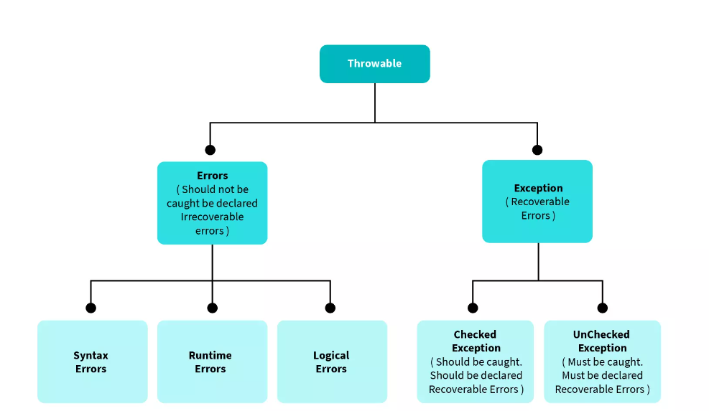
Since errors are generally caused by problems that cannot be recovered from, it’s usually not appropriate for a program to catch errors. Instead, the best course of action is usually to log the error and exit the program.
There are 3 types of Errors:
- Syntax Error
- Runtime Error
- Logical Error
Syntax Errors
Syntax Errors are those errors detected during the compilation phase by the compiler when your code does not follow the syntactical rules of the programming language you are using. e.g, missing semi-colon(s), missing parenthesis, using else if() block directly without using if block first, returning nothing from the function when the return type is some data type, say, int, etc.
Runtime Errors
Runtime Errors occur during the execution of a program, due to lack of system resources, or due to irrelevant input by the user. The compiler has no idea whatever how to detect these kinds of errors. For example, dividing a number by 0, accessing an element from an array that is out of range, trying to convert an invalid string to an integer, out of memory error, etc.
Logical Errors
Logical Errors are those errors where the program returned incorrect results when you were expecting the desired result. These occur due to some mistake in the code logic made by the programmer. The compiler cannot detect these errors. The user can just understand them after seeing the output. These are also known as Semantic Errors.
For example, When the programmer writes mistakenly, if(i = 1) instead of, if(i == 1): This will change the program's narrative.

Exceptions, used to handle errors that can be recovered from within the program. Exceptions are represented by the Exception class and its subclasses. Some common examples of exceptions in Java include:
- NullPointerException: Thrown when a null reference is accessed.
- IllegalArgumentException: Thrown when an illegal argument is passed to a method.
- IOException: Thrown when an I/O operation fails.

Example: NullPointerException
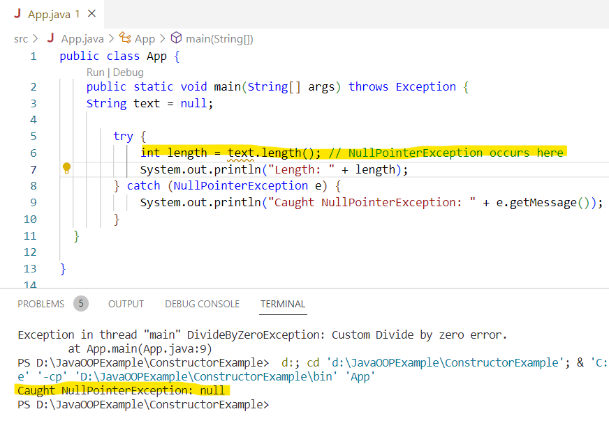
IllegalArgumentException
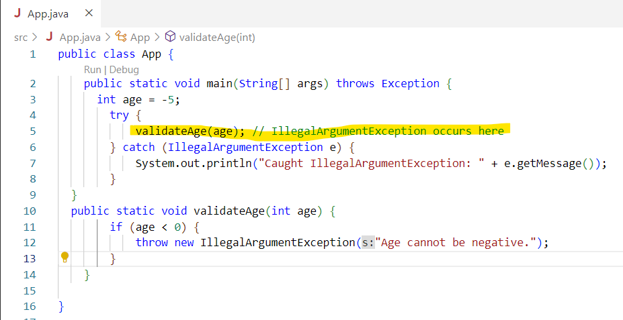

There are 2 types of Exceptions:
Checked Exceptions
Unchecked Exceptions

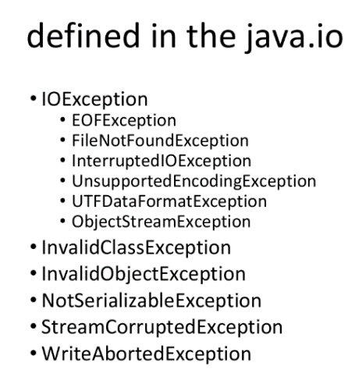
Checked Exceptions
Exceptions that occur and can be detected at compile time are known as Checked Exceptions. These exceptions prevent the program from running, and so they must be handled by the programmer. Otherwise, the program will not get compiled. For Example, ClassNotFoundException, FileNotFoundException, IOException, SQLException, etc.
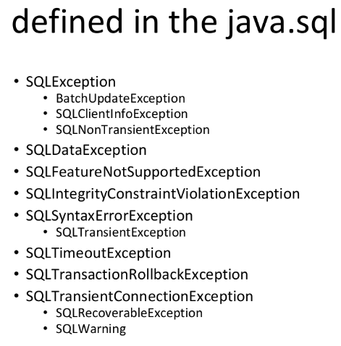
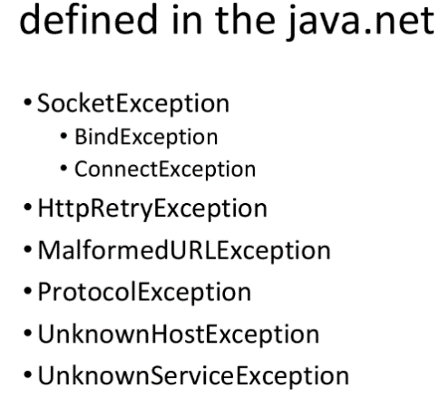

Unchecked Exceptions

Exceptions that occur at the time of the program execution, i.e., at runtime, are known as Unchecked Exceptions. These exceptions are ignored at the time of compilation.
They occur due to the following main reasons:

Invalid User Input

Bugs in the program

Improper usage of an API

Memory limit exceeded

Examples of unchecked exceptions include ArrayIndexOutOfBoundsException, NullPointerException, IllegalArgumentException, ArithmeticException, NumberFormatException, etc.

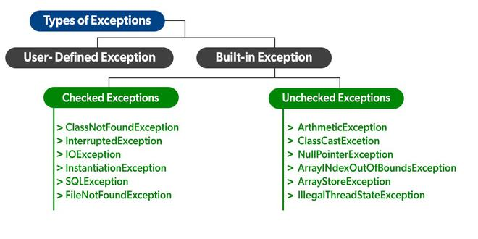

Difference between Errors and Exceptions in Java

S.No | Errors | Exceptions
1. | The error indicates trouble that primarily occurs due to the lack of system resources. | The exceptions are the issues that can appear at runtime and compile time.
2. | It is not possible to recover from an error. | It is possible to recover from an exception.
3. | In java, all the errors are unchecked. | In java, the exceptions can be both checked and unchecked.
4. | The system in which the program is running is responsible for errors. | The code of the program is responsible for exceptions.
5. | They are described in the java.lang.Error package. | They are described in java.lang.Exception package

Why we need to deal with exception?
Exception handling is a critical aspect of programming, and there are several reasons why we need to deal with exceptions:

1. Error detection and reporting: Exceptions allow us to identify and handle errors or exceptional situations that may occur during program execution. Instead of the program crashing abruptly, exceptions provide a mechanism to detect errors and report them in a controlled manner.

2. Program stability and robustness: Exception handling helps in creating stable and robust software. By catching and handling exceptions, we can prevent the program from terminating unexpectedly and provide graceful error recovery or fallback mechanisms. This ensures that the program continues to execute and doesn't leave the system in an inconsistent state.

3. Separation of concerns: Exception handling allows for the separation of normal program logic from error handling code. By handling exceptions separately, we can keep the main code clean and focused on its primary purpose, improving code readability and maintainability.

4. User-friendly experience: Exception handling enables us to provide meaningful error messages or feedback to the users. Instead of displaying mysterious error codes or crashing, we can catch exceptions and present user-friendly messages, guiding users on how to resolve or recover from errors.

5. Debugging and troubleshooting: Exceptions can provide valuable information for debugging and troubleshooting purposes. This information can be used to identify the root cause of the issue and fix the problem effectively.

6. Resource management: Exception handling plays a crucial role in proper resource management. For example, if a file is opened for reading and an exception occurs while reading from it, the exception handling code can ensure that the file is closed properly, preventing resource leaks.

Catching and Handling Exception:
In Java, exception handling is done using the "try-catch" blocks. Here's how you can catch and handle exceptions in Java:

1. Try block: The code that may throw an exception is placed within a "try" block. It is enclosed within curly braces.

try {
// Code that may throw an exception
// ...
}

2. Catch block(s): Following the try block, one or more "catch" blocks can be added to handle specific types of exceptions. Each catch block specifies the type of exception it can handle.
try {
// Code that may throw an exception
// ...
} catch (ExceptionType1 e) {
// Exception handling for ExceptionType1
// ...
} catch (ExceptionType2 e) {
// Exception handling for ExceptionType2
// ...
}
You can have multiple catch blocks for different exception types. When an exception occurs, the catch blocks are evaluated sequentially to find a matching catch block. If a matching catch block is found, the code within that catch block is executed.

3. Handling the exception: Inside each catch block, you can include code to handle the exception. This could involve displaying an error message, logging the exception, performing error recovery, or any other appropriate action.
try {
// Code that may throw an exception
// ...
} catch (ExceptionType1 e) {
// Exception handling for ExceptionType1
// ...
// e.printStackTrace(); // Print stack trace (optional)
} catch (ExceptionType2 e) {
// Exception handling for ExceptionType2
// ...
}
4. Optional finally block: After the catch block(s), you can include an optional "finally" block. The code within the finally block is executed regardless of whether an exception occurred or not. It is typically used for cleanup operations, such as releasing resources like open files or closing database connections.
try {
// Code that may throw an exception
// ...
} catch (ExceptionType1 e) {
// Exception handling for ExceptionType1
// ...
} catch (ExceptionType2 e) {
// Exception handling for ExceptionType2
// ...
} finally {
// Cleanup code (optional)
// ...
}

The finally block will always execute, even if an exception is thrown and caught or if an exception is not thrown at all.
By catching and handling exceptions in Java, you can prevent your program from crashing, provide appropriate error handling, and ensure proper resource management.

Exception Class:
- In Java, the Exception class is a fundamental class that serves as the base class for all exceptions.
- It is part of the Java java.lang package
- The Exception class itself is an abstract class, so you cannot directly instantiate it.
- It also provides the basis for creating custom exception classes by extending it.
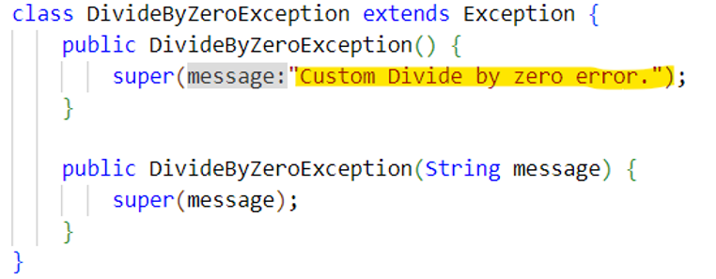
In this example, DivideByZeroException is a custom exception class that extends the Exception class. By extending Exception, the custom exception inherits all the properties and behaviors of the Exception class.
- By extending the Exception class, you can create custom exception classes that suit your application's specific needs. Helps to give error in meaningful way.
The Exception class provides several constructors and methods to work with exceptions. Some commonly used methods include:
- getMessage(): Returns the detail message string of the exception.
- getCause(): Returns the cause of the exception, or null if the cause is unknown.
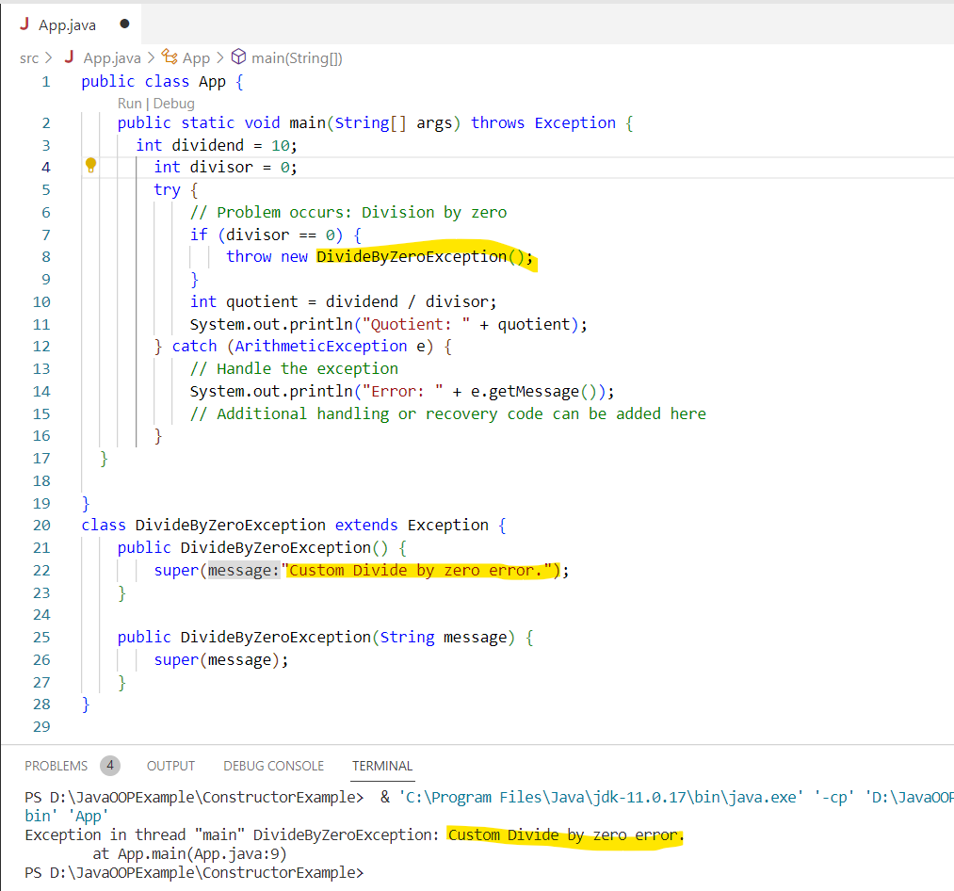
- printStackTrace(): Prints the stack trace of the exception to the standard error stream.

